[LOCAL LOGO]
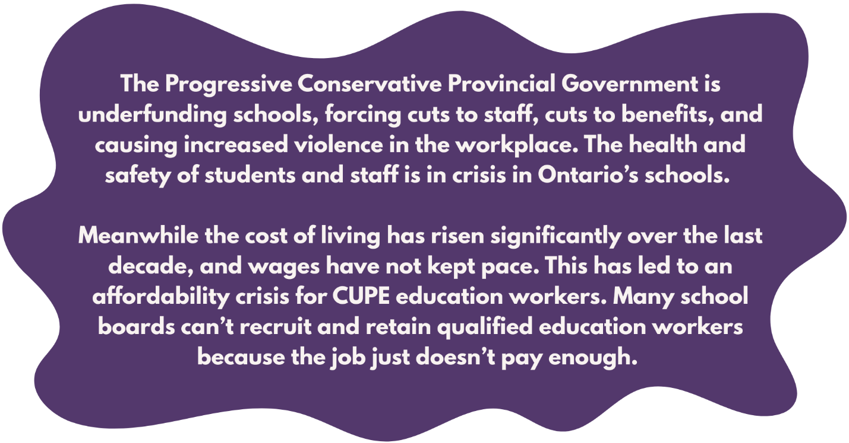
SIGN THE STRIKE PLEDGE!

Education workers deserve better.
Students deserve better.
CUPE education workers in all classifications across all school boards in Ontario are uniting to resist cuts and reclaim schools.
HAVE YOU SIGNED THE STRIKE PLEDGE?
Talk to your work site leader about signing the pledge to strike if necessary to win a contract that addresses the violence, understaffing and workload crisis in schools.

Contact [insert name and contact info [email and/or phone number] for Local Mobilization Team Lead] to be connected to a member of the local’s Contract Action Team.

